Neural Networks and Stock Market Timing
-Intermarket Analysis

Donn S. Fishbein, MD, PhD
Neuroquant.com

Wanna Buy Some Swampland in Florida? A View on System Trading. Stocks, Futures and Options, August 2004, pp. 43-56

“You don’t have to be a timer to do well in the market.” –Jeremy Siegel, Russell E. Palmer Professor of Finance, Wharton School of the University of Pennsylvania, quoted in Stocks, Futures and Options, September 2004, pp. 15-108.

“In an uncertain world, trend following may be the most rational approach to the markets.” – John W. Henry, Chairman, John W. Henry and Company and Owner, Boston Red Sox, quoted in Stocks, Futures and Options, July 2004, pp. 37-43.

These Boots are Made for Random Walking. Stocks, Futures and Options, November 2004, pp. 30-38.

“[Motley] Fools aren’t believers in technical analysis.” –Motley Fool School as quoted on Google.com Defines:

There is no shortage of advice against timing the financial markets. Only a rare dissenting voice can be heard. Market timing refers to buying and selling financial instruments in response to whether one believes the market is rising or falling. These beliefs may come from intuition, reaction to news events, scientific calculation, astrology, or an endless array of other indicators. Technical analysis (Fosback 1991, Arnold 1993) is one tool used for market timing, and the subject of this paper.

Here’s a reasonable definition of technical analysis from Investorwords.com:

“…method of evaluating securities by relying on the assumption that market data, such as charts of price, volume, and open interest, can help predict future (usually short-term) market trends. Unlike fundamental analysis, the intrinsic value of the security is not considered. Technical analysts believe that they can accurately predict the future price of a stock by looking at its historical prices and other trading variables. Technical analysis assumes that market psychology influences trading in a way that enables predicting when a stock will rise or fall. For that reason, many technical analysts are also market timers, who believe that technical analysis can be applied just as easily to the market as a whole as to an individual stock.”

The most frequent criticism of technical analysis is that is just doesn’t work. This is easy to disprove. Let’s look at two major market moves this decade, using the basic technical analysis tool of simple moving averages (SMA).

SMA_{n} is defined as the average value over the past n periods. A common usage is to calculate the SMA of the closing daily price of a stock or index over the past n days. The effect is to smooth out a time-price plot by eliminating higher frequency components, acting as a low-pass filter. As n increases the degree of smoothing increases, and the cutoff frequency of the filter decreases. Common values for n include 10 days (short term), 50 days (intermediate term), and 200 days (long term). In general, when the price (SMA₁) or a shorter term SMA is greater than a longer term SMA, the market is thought to be in an uptrend, and vice versa. If PRICE < SMA₁₀ < SMA₅₀ < SMA₂₀₀, the market is in a downtrend.

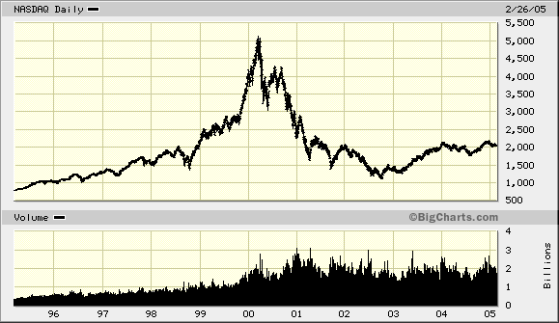
Figure 1: NASDAQ Composite Index 1995-2005

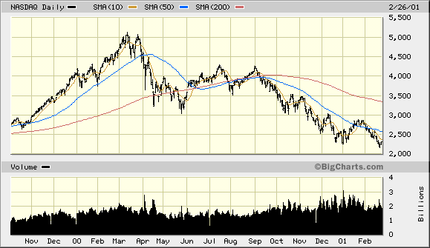Figure 2: NASDAQ Crash April 2000 – Feb 2001 with 10, 50 and 200 day SMA

Figure 1 shows the now familiar meteoric rise of the NASDAQ composite index and the equally precipitous crash from 1999 to 2001. A closer look in Figure 2, the period from November 1999 to February 2001 shows the relationship of the closing price to 10, 50 and 200 day SMA. As the NASDAQ begins its slow, inexorable decline the close crosses below SMA₁₀, then SMA₅₀, and finally SMA₂₀₀. Meanwhile SMA₁₀ crosses below SMA₅₀ and then SMA₂₀₀, and finally SMA₅₀ crosses below SMA₂₀₀. These chart findings gave clear evidence of a substantial market decline, and offered time to escape the long side of the market.

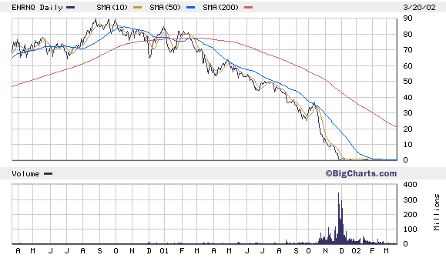
Figure 3: The death spiral of Enron, 2001

Figure 3 shows the decline of Enron Corp. stock from 90 to 0 in the space of a year. Again, with only a rare deviation, the relationship price < SMA₁₀ < SMA₅₀ < SMA₂₀₀ was established early in the stock price decline and maintained until the stock flat-lined. Although the disastrous news about Enron’s fictitious businesses didn’t become public until late in the stock’s decline, it is clear that somebody knew the news earlier, and those who didn’t could have followed the technical indicators and exited with most of their capital intact.

Even though analysis based on price and 10, 50 and 200 day SMA is routine, it might be fair to criticize the two preceding examples as being selected with hindsight (actually, the NASDAQ example was initially presented at a TCF talk in May, 2000, before the full extent of the NASDAQ decline was known, with the interpretation that the market was in decline.) A third example uses a system developed over 30 years ago, the 4% Swing investment strategy, developed by Ned Davis of Ned Davis Research. The system is easy to explain and quickly disproves the theory that market timing doesn’t work. Marty Zweig popularized the percent swing system in a 1986 book entitled Winning on Wall Street (Zweig, 1986). The system logic is very simple. Originally based on weekly closes for the Value Line Composite index, the system buys after a 4% rise above a prior weekly low and sells after a 4% decline from a prior weekly high. The system can be followed on a chart without a computer. The system was profitable during a 19-year back-test period from 1966 to 1985, prior to its publication, and has remained profitable since its publication.

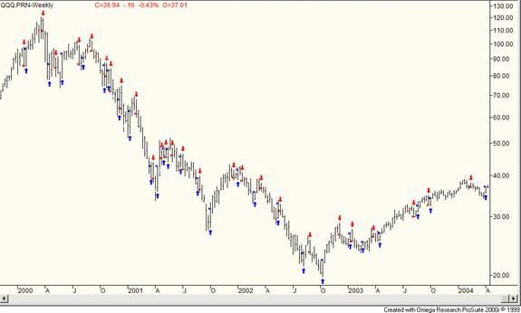Figure 4 - 4% Swing System NASDAQ-100 Trust (QQQ) 1999-Apr 2004, Weekly Bars; Buys Indicated By Up Arrows Below Price Bars, Sells By Down Arrows Above Price Bars

The system meets the criteria of broad applicability and robustness for traditional technical analysis systems. First, it works well across different instruments, such as stocks, market indices, and futures. The above chart shows the indicator applied to the Nasdaq-100 exchange traded fund QQQQ, which didn’t come into existence until decades after the first description of the percent swing system. Second, it works well across different time frames such as hour, day, and week bars. Finally, its parameters, the per cent upswing necessary to trigger a buy and the percent downswing necessary to trigger a sell, are not particularly critical. The system works with a wide range of values, and is therefore robust. Although its gains are not spectacular, it has beaten market averages in both back tests and forward tests since its introduction. Using the 4% swing system over the past four decades would have allowed you to miss much of the 1973-74 bear market, miss the 1987 crash entirely, and miss most of the recent bear market.
The 4% swing system logic guarantees that a significant move in either direction will not be missed. While adequate to demonstrate that technical analysis has merits, the 4% swing system also demonstrates the weaknesses of simple non-adaptable systems with fixed parameters. Although its logic is good at capturing trending market moves, it does poorly in a range bound market. It subjects its adherents to whipsaws, in which signals are triggered just as a minor move is completed and the market reverses to the opposite direction. A more adaptable system might be able to recognize trending from trend-less markets, and only fire signals when a trending market was detected. Alternately, parameters could be dynamically adjusted to better fit current market conditions.
Artificial neural networks (ANN) and genetic algorithms (GA) allow the selection of indicators and optimization of parameters. Artificial neural networks simulate the workings of biological neural networks, in which information is stored as connection weights between nodes. Training involves presenting inputs to a neural network and adjusting connection weights to progressively minimize error in the generated output. Genetic algorithms optimize parameters by simulating a process of reproduction with crossover and mutation, and evaluation of the fittest species. Introductory information on these topics is available from a number of sources (Zirilli 1997, Fishbein 2001-2004, Neuroquant.com, Chen 1996).

Intermarket analysis (Murphy, 2004) predicts the behavior of one financial instrument, such as a stock index, by using the behavior of other financial instruments, such as oil or gold prices, or Treasury bond rates. The assumption is that various financial markets are interrelated, and changes in one may predict changes in another. Although some relationships are well established (stock prices and interest rates), many relationships are complex, obscure, non-linear, and non-apparent. As the number of market instruments under consideration increases, the number of their potential interrelationships increases exponentially. ANNs offer an excellent tool for exploring intermarket relationships.

Consider the Standard and Poor’s 500 Stock Index, composed of 500 of the largest corporations in the United States. Given the nature of the companies within this index, which represent a broad spectrum of industries, it is reasonable to assume that the performance of these companies is related to broad economic factors.

Figure 5: A portion out-of-sample trades generated by an intermarket ANN – S&P 500

An ANN is constructed to predict the per cent change in opening value of the S&P 500 index 1 day hence. The inputs include the closing price, daily volume, moving averages of the closing price, the 10 year US Treasury bond price, and the indices for crude oil and gold. The network is trained on 5 years of values, and tested out-of-sample for 1 year. Allowing a deduction for trade commissions and slippage, this system returned 30.5% annualized during the out-of-sample testing period, with 70% of trades profitable. During the same period, the S&P index rose 8.2%. A portion of the out-of-sample period is shown in Figure 5.

This preliminary result shows that ANNs offer a simple, direct way to implement intermarket analysis in developing a trading system for the S&P 500 index. It is by no means the best result that can be obtained with ANNs and GA. In comparison, the latest iteration of the AMA–2SMA system, which was initially presented at a past TCF talk (Fishbein 2001), showed an annualized return of 53.4% over the same period for the S&P 500 index. This in part represents a far longer development period for the AMA-2SMA system as compared to this nascent S&P 500 intermarket system. Continued development may improve performance and even challenge the results of the more mature AMA-2SMA system.

Conclusion

Timing the market increases profit potential by avoiding the majority of price action opposite in direction to positions held. Mechanical trading systems offer a number of advantages over discretionary systems, including but not limited to, the exclusion of emotion from trading decisions and the ability to extensively back-test potential trading systems. Neural networks with genetic optimization offer a tool that can produce mechanical trading systems that are adaptable to changing market conditions. Successful implementation of such a system requires an understanding of the strengths and limitations of artificial neural networks, as well as extensive testing (Fishbein 2001).
References

Arnold, Curtis M. Timing The Market. Weiss Research, Inc., 1993

Chen CH. Fuzzy Logic and Neural Network Handbook. IEEE Press, 1996.
Fishbein DS. Trading Financial Markets with Neural Networks and Genetic Algorithms. Trenton Computer Festival Proceedings, 2001.
Fishbein DS. Neural Networks and Genetic Algorithms: Another Tools for the Technical Analysis of Financial Markets. Trenton Computer Festival Proceedings, 2002.
Fishbein DS. Mechanical Stock Trading Systems That Really Work. Trenton Computer Festival Proceedings, 2003.
Fishbein DS. How to time the stock market Using Artificial Neural Networks and Genetic Algorithms. Trenton Computer Festival Proceedings, 2004.
Fosback, Norman G. Stock Market Logic. Dearborn Financial Publishing, Inc., 1991.
Murphy John. Intermarket Analysis. Wiley Trading, 2004.
Neuroquant.com: www.neuroquant.com
Zirilli, Joseph S. Financial Prediction Using Neural Networks. International Thomson Computer Press, 1997.
Zweig, M. Winning of Wall Street. 1986, 1997(revised), Warner Books.

